Programming Concepts
Week 3 CREDIT Submission Tasks Template

Student ID: _____103055993________________
Student Name: ___________Mario Stavreski___________________

Credit Task 7 set of screenshots with valid seating category and invalid quantity

Paste the screen capture of the tickets sale calculator web page as shown by the browser here.
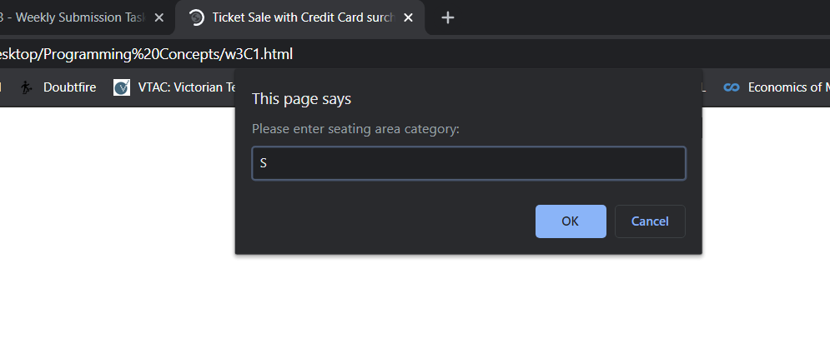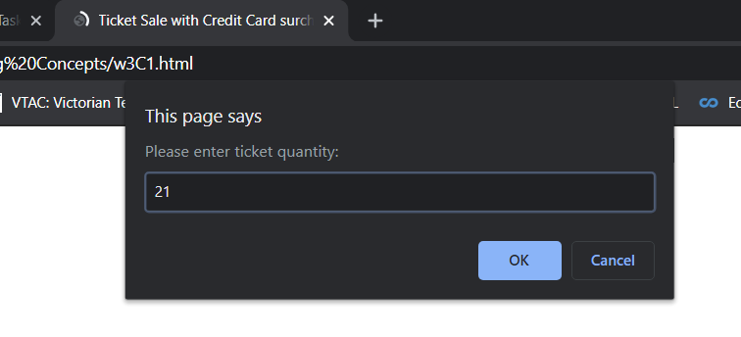
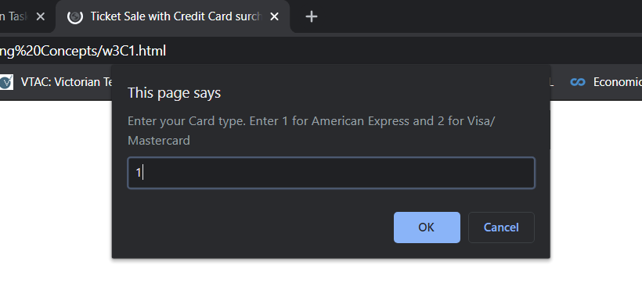
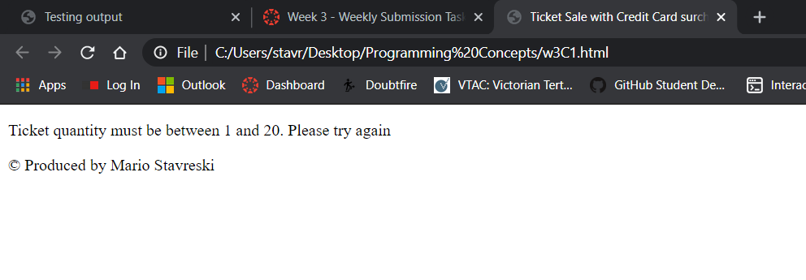

Credit Task 7 set of screenshots with invalid seating category and valid quantity

Paste the screen capture of the tickets sale calculator web page as shown by the browser here.
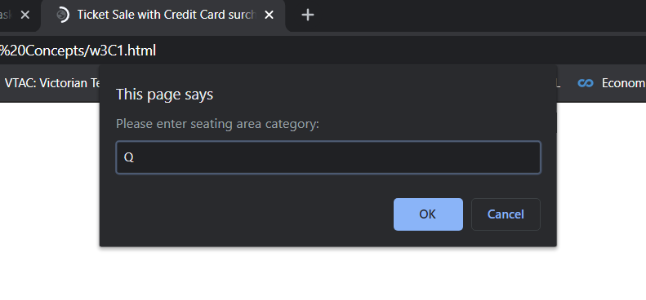
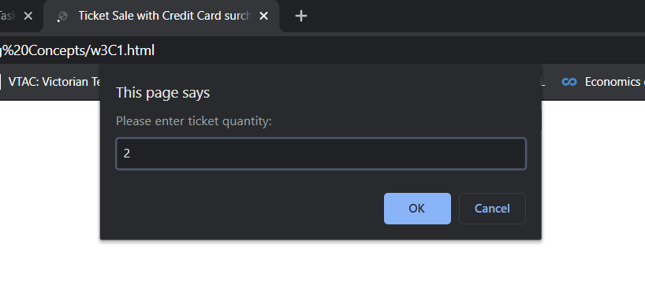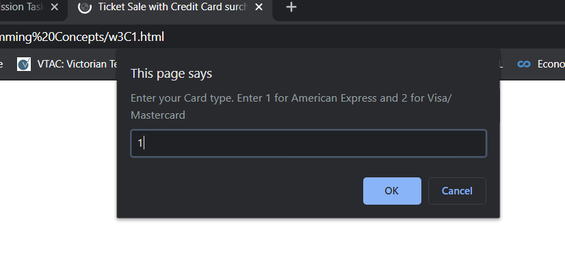
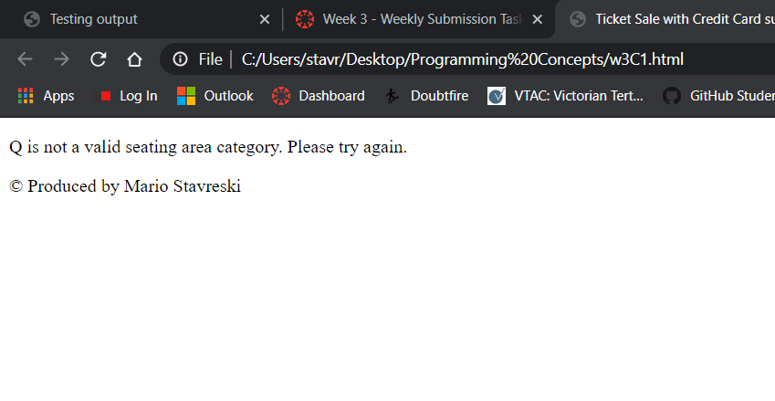

Credit Task 7 set of screenshots with invalid inputs

Paste the screen capture of the tickets sale calculator web page as shown by the browser here.
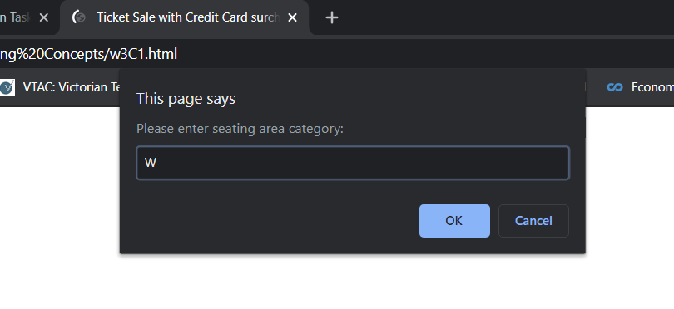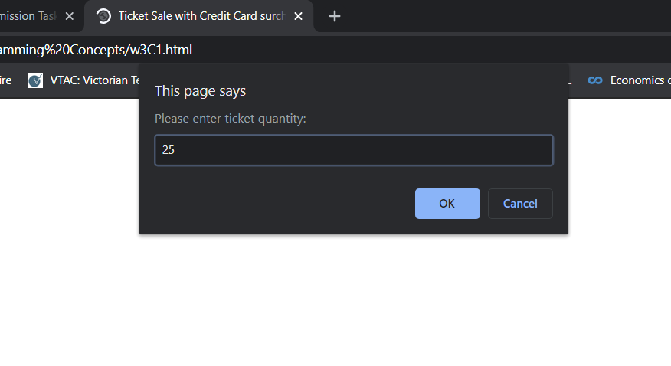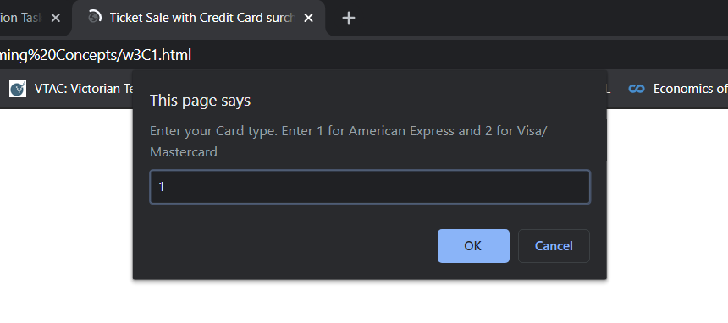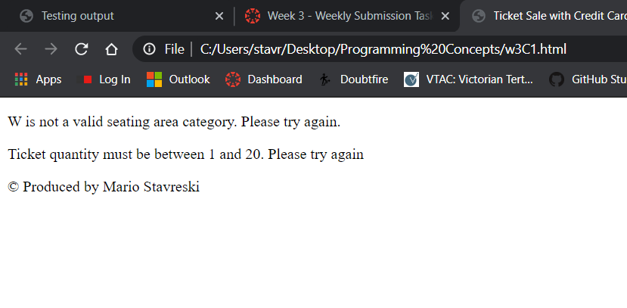

Credit Task 7 set of screenshots with invalid card type entered

Paste the screen capture of the tickets sale calculator web page as shown by the browser here.
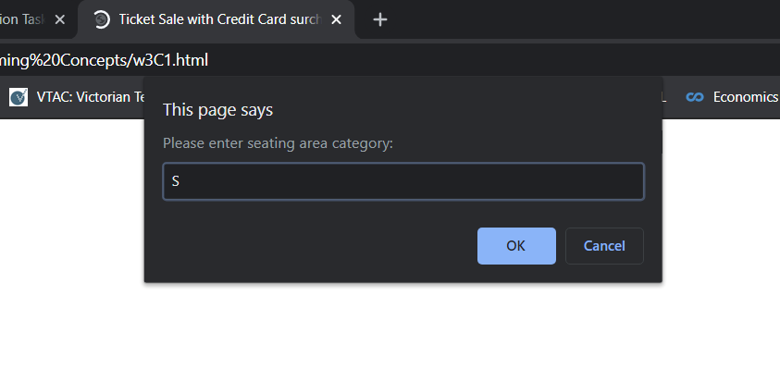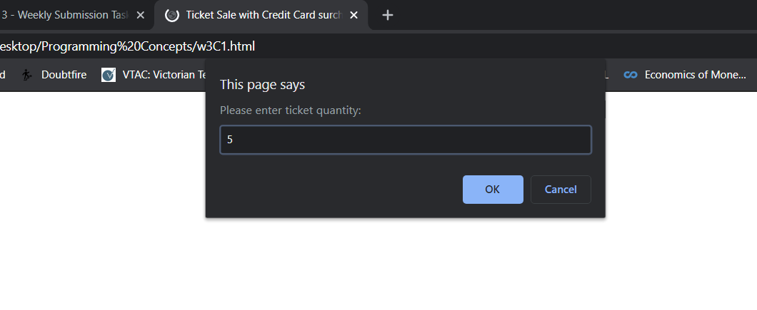
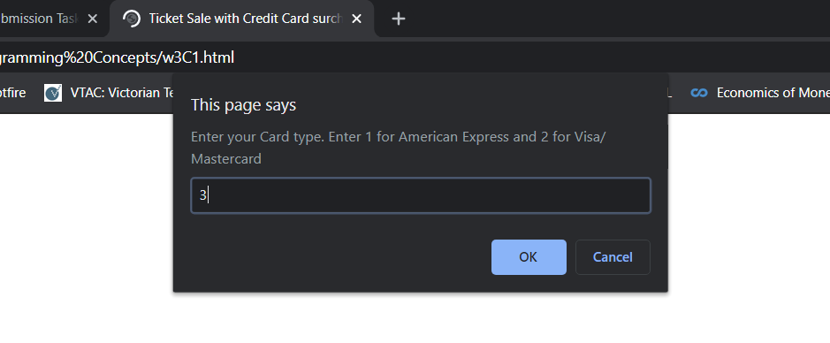
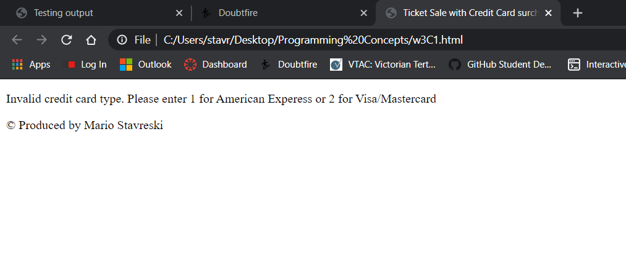

Credit Task 7 set of screenshots with valid seating category and valid quantity and payment by AmEx

Paste the screen capture of the tickets sale calculator web page as shown by the browser here.
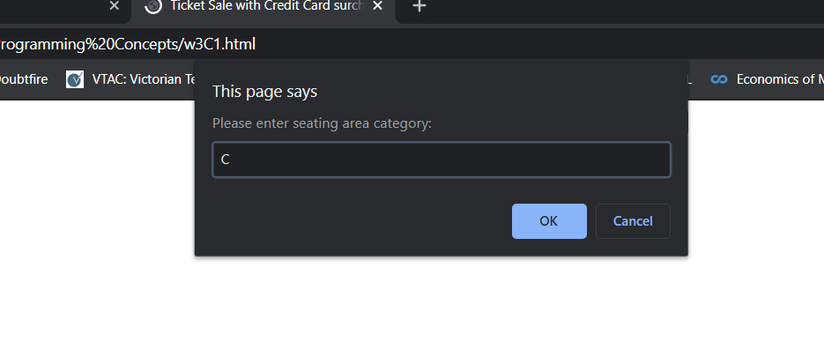
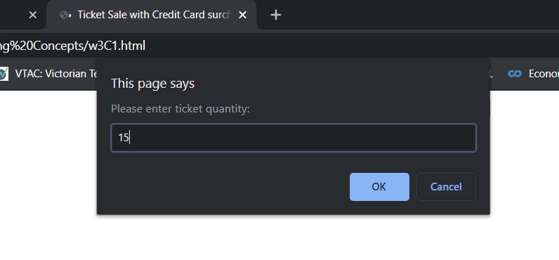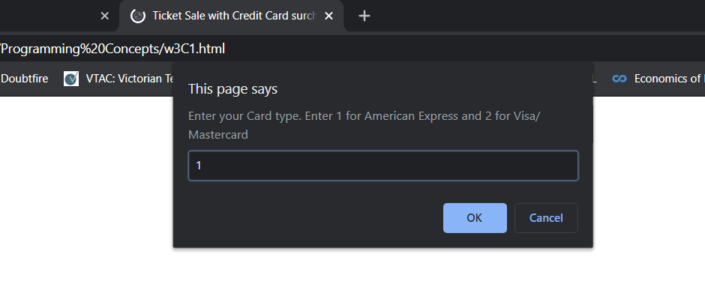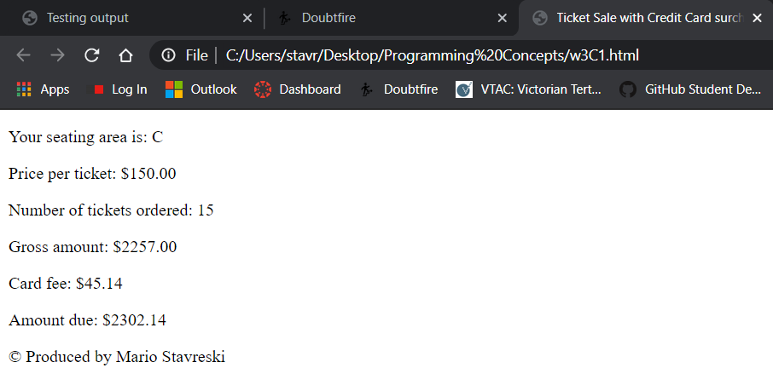

Credit Task 7 set of screenshots with valid seating category and valid quantity and payment by Visa or Mastercard

Paste the screen capture of the tickets sale calculator web page as shown by the browser here.
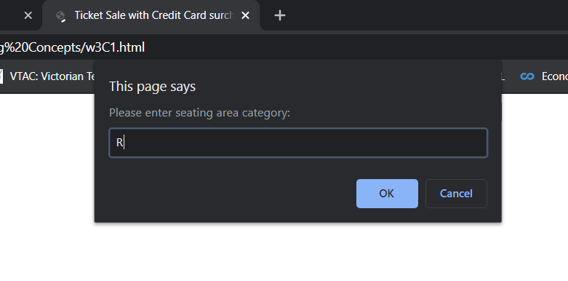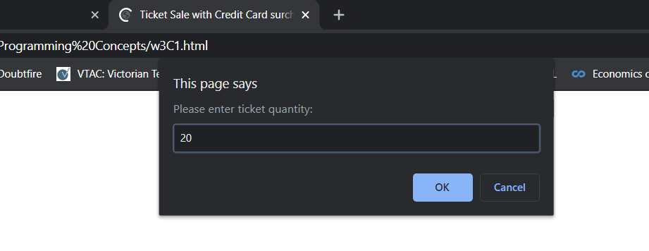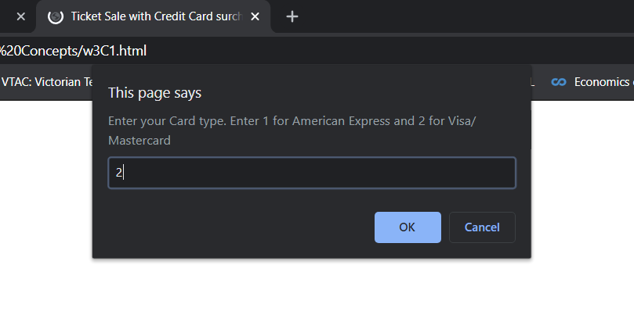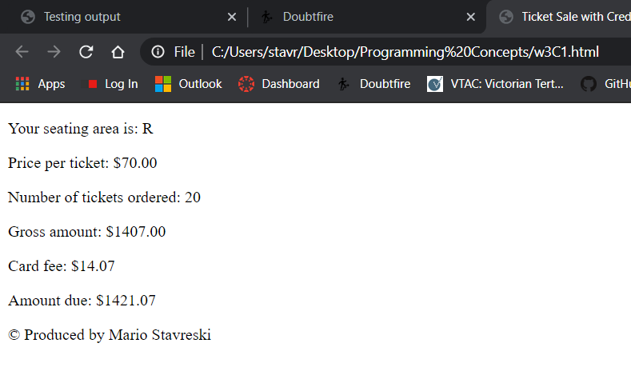

Credit Task 7 html code

Paste the html code of the same page here.
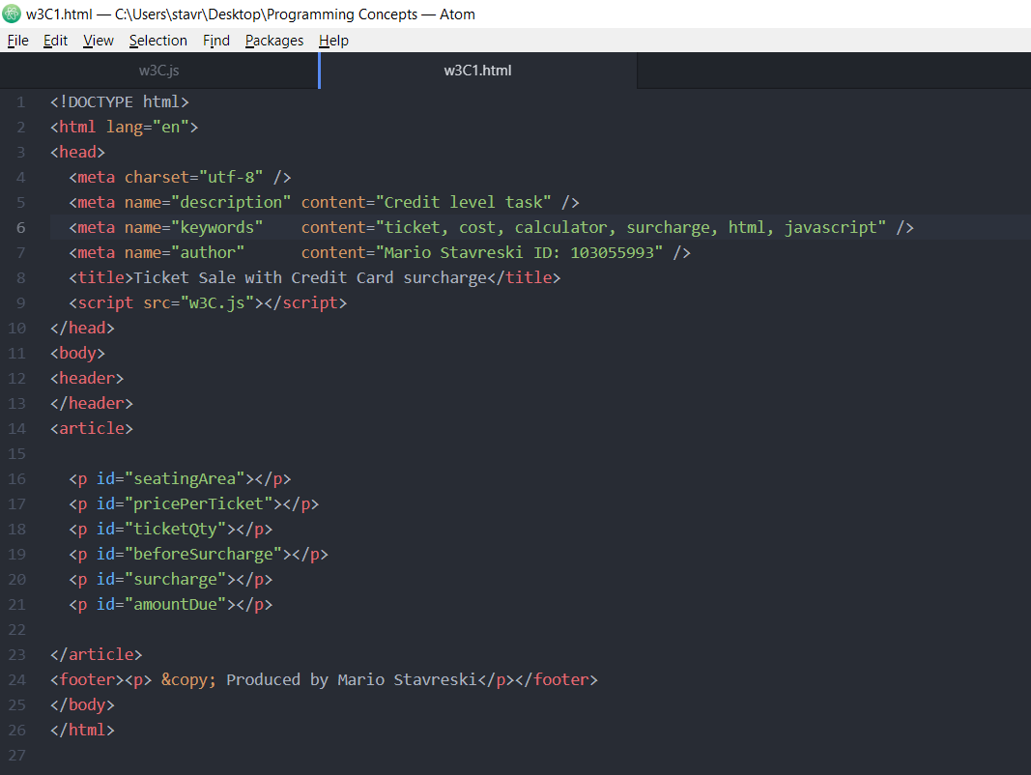

Credit Task 7 JavaScript code

Paste the JavaScript code of the same page here.
